Test Case: tc002_SPX_Dev5_Crear_Requisicion_Spot_Con_FAD_Tipo_Cobro_CC
Step 1 - Enter username and password and click to button Enter : Credentials Entered
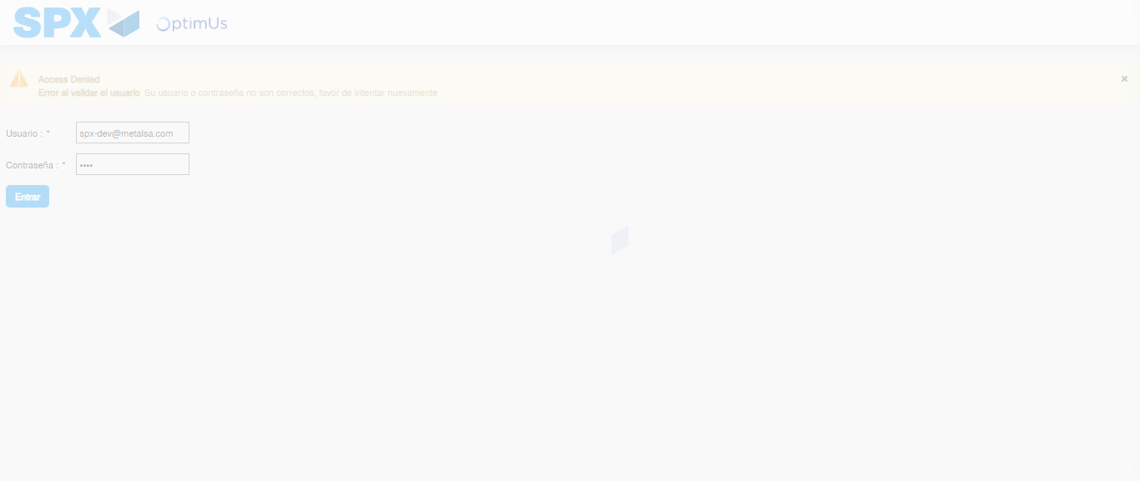Image file-name: QC_Testing-tc002_SPX_Dev5_Crear_Requisicion_Spot_Con_FAD_Tipo_Cobro_CC-1789484269006

Step 2 - Select to UEN and Access to Spot Buy Requisitions : UEN Correctly selected and Correct access
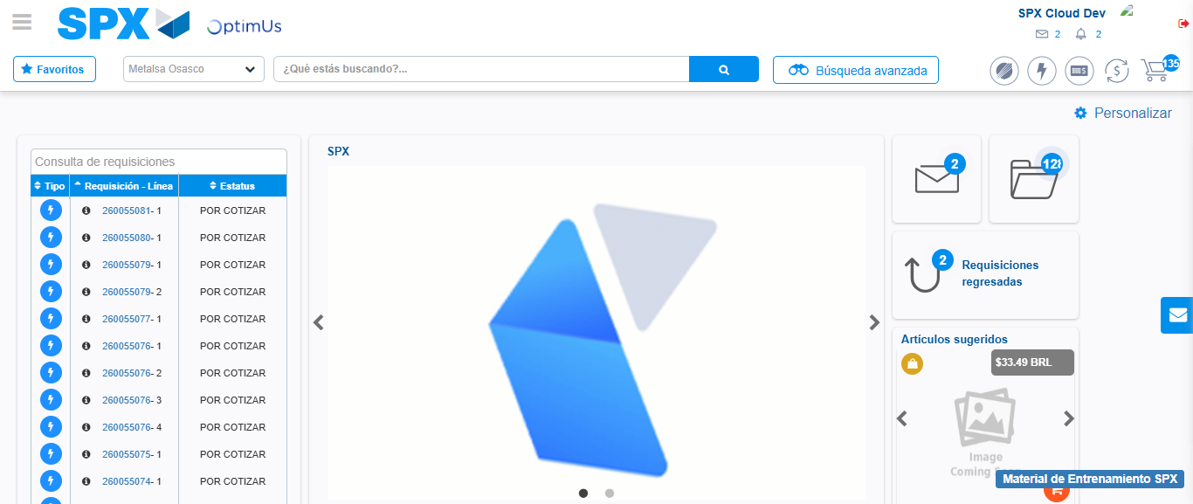Image file-name: QC_Testing-tc002_SPX_Dev5_Crear_Requisicion_Spot_Con_FAD_Tipo_Cobro_CC-1789484299737

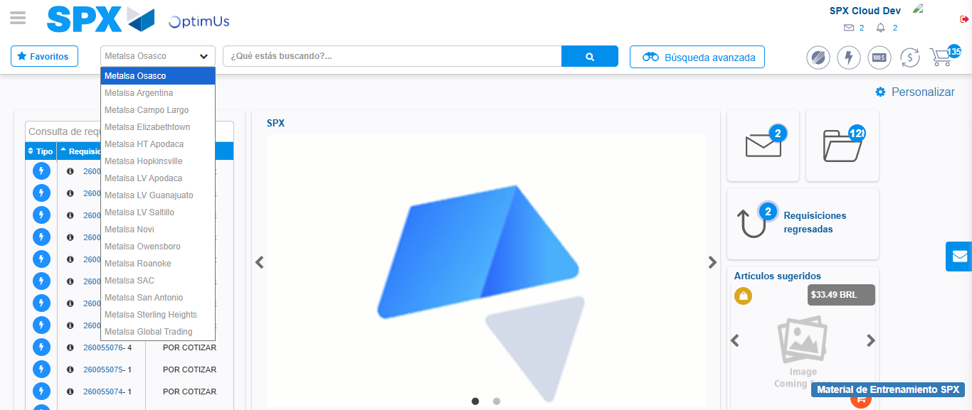Image file-name: QC_Testing-tc002_SPX_Dev5_Crear_Requisicion_Spot_Con_FAD_Tipo_Cobro_CC-1789484300297

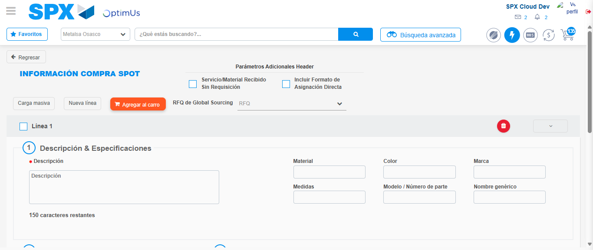Image file-name: QC_Testing-tc002_SPX_Dev5_Crear_Requisicion_Spot_Con_FAD_Tipo_Cobro_CC-1789484304909

Step 3 - Add FAD to Requisition: FAD Successfully Added
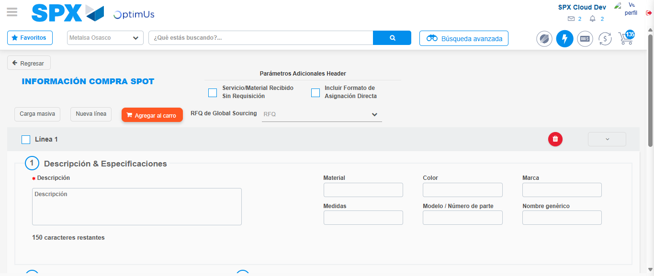Image file-name: QC_Testing-tc002_SPX_Dev5_Crear_Requisicion_Spot_Con_FAD_Tipo_Cobro_CC-1789484305146

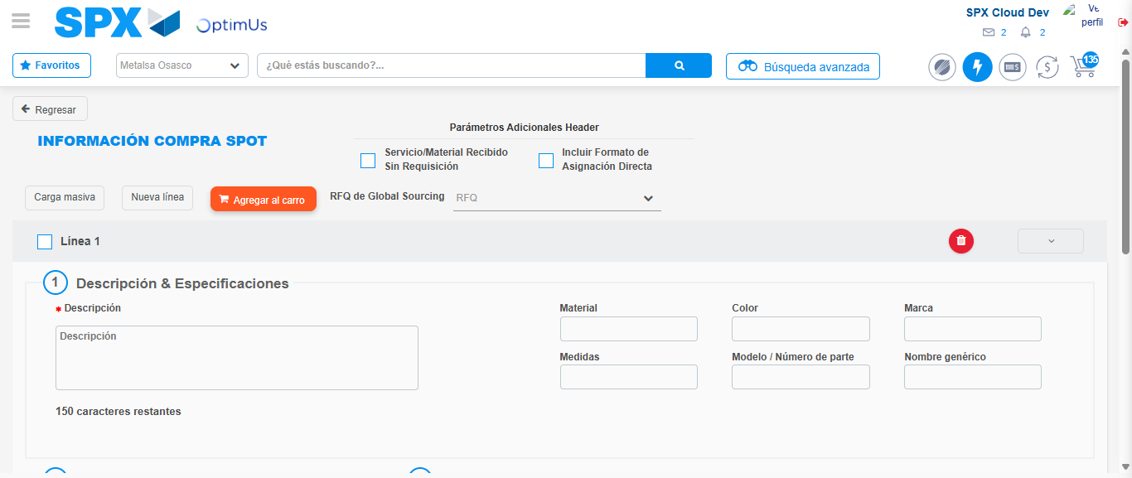Image file-name: QC_Testing-tc002_SPX_Dev5_Crear_Requisicion_Spot_Con_FAD_Tipo_Cobro_CC-1789484305290

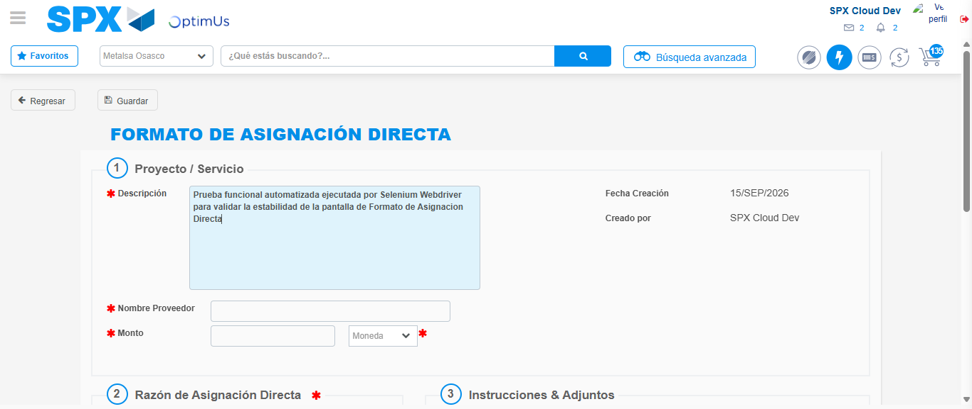Image file-name: QC_Testing-tc002_SPX_Dev5_Crear_Requisicion_Spot_Con_FAD_Tipo_Cobro_CC-1789484308017

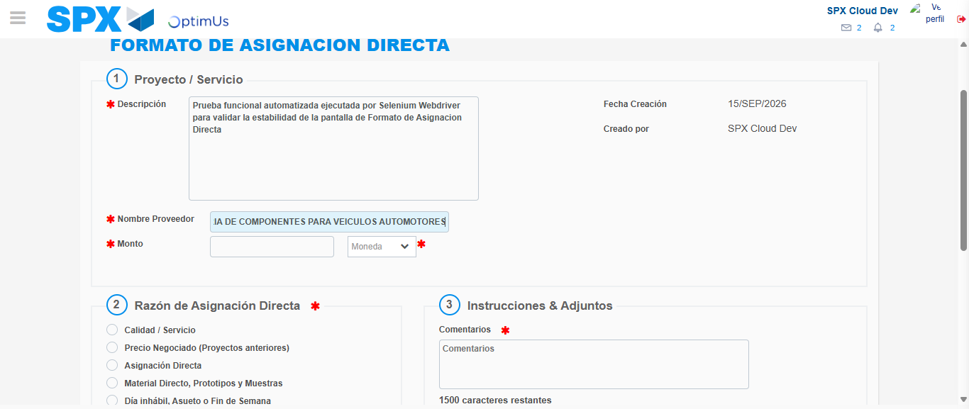Image file-name: QC_Testing-tc002_SPX_Dev5_Crear_Requisicion_Spot_Con_FAD_Tipo_Cobro_CC-1789484316378

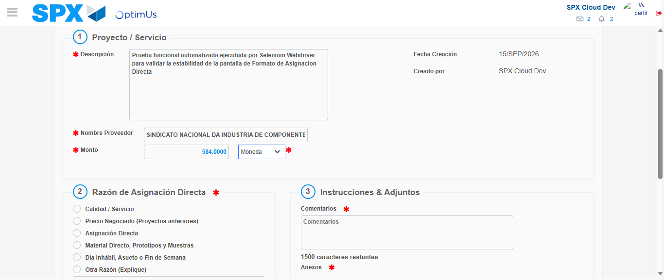Image file-name: QC_Testing-tc002_SPX_Dev5_Crear_Requisicion_Spot_Con_FAD_Tipo_Cobro_CC-1789484316786

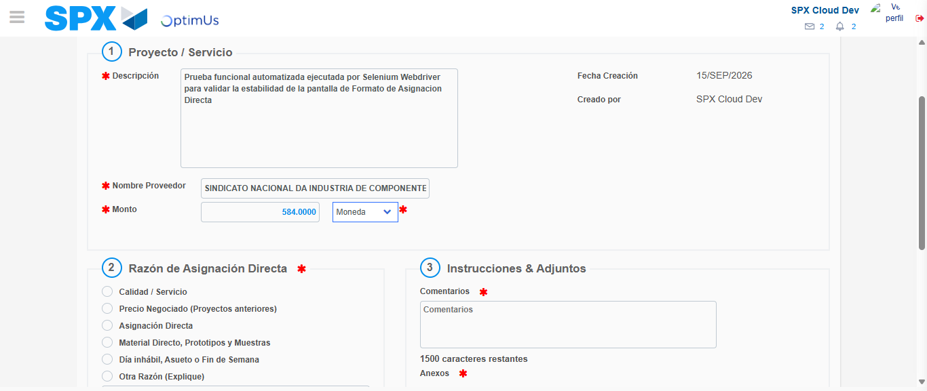Image file-name: QC_Testing-tc002_SPX_Dev5_Crear_Requisicion_Spot_Con_FAD_Tipo_Cobro_CC-1789484316971

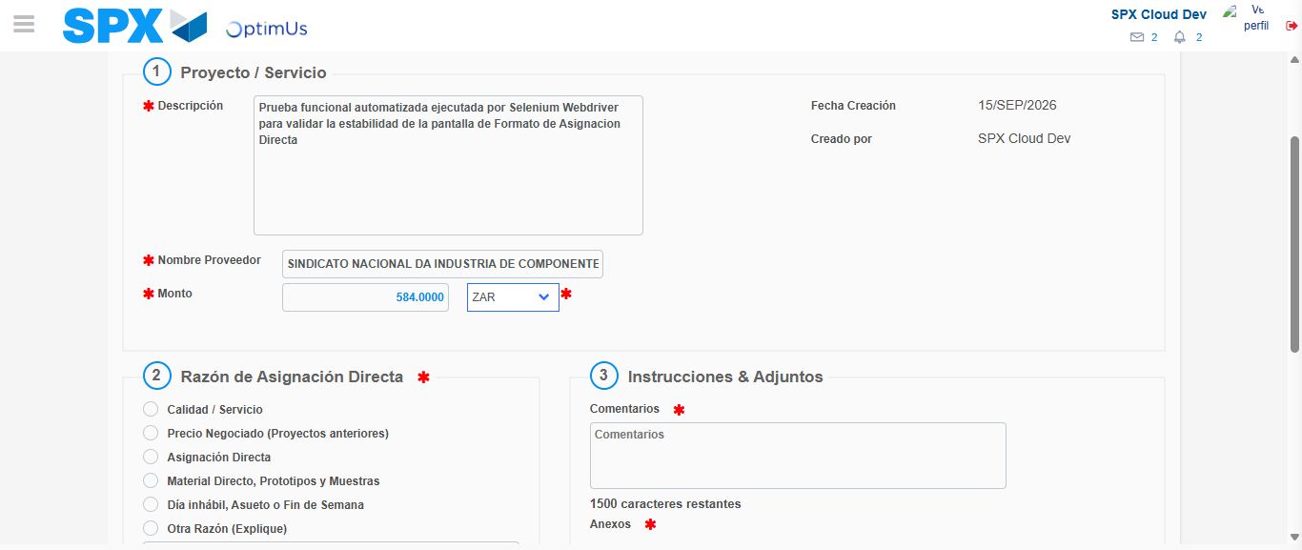Image file-name: QC_Testing-tc002_SPX_Dev5_Crear_Requisicion_Spot_Con_FAD_Tipo_Cobro_CC-1789484317298

Image file-name: QC_Testing-tc002_SPX_Dev5_Crear_Requisicion_Spot_Con_FAD_Tipo_Cobro_CC-1789484317451

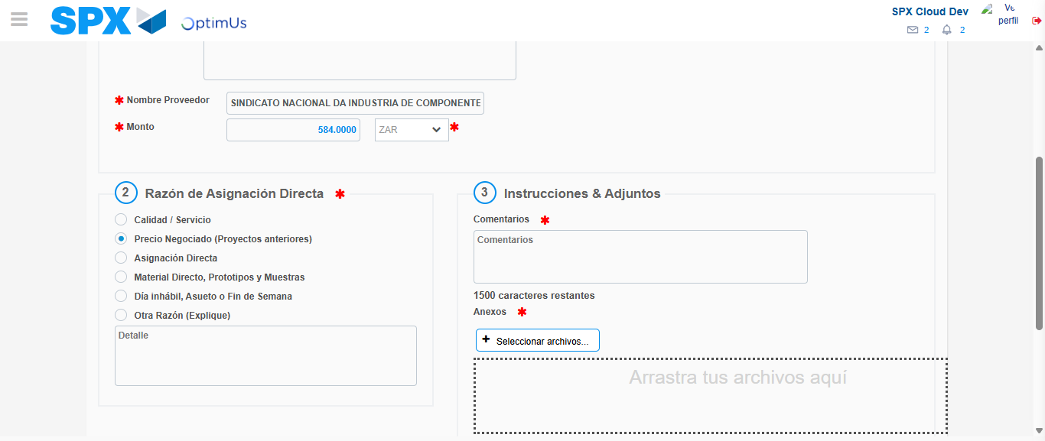Image file-name: QC_Testing-tc002_SPX_Dev5_Crear_Requisicion_Spot_Con_FAD_Tipo_Cobro_CC-1789484318247

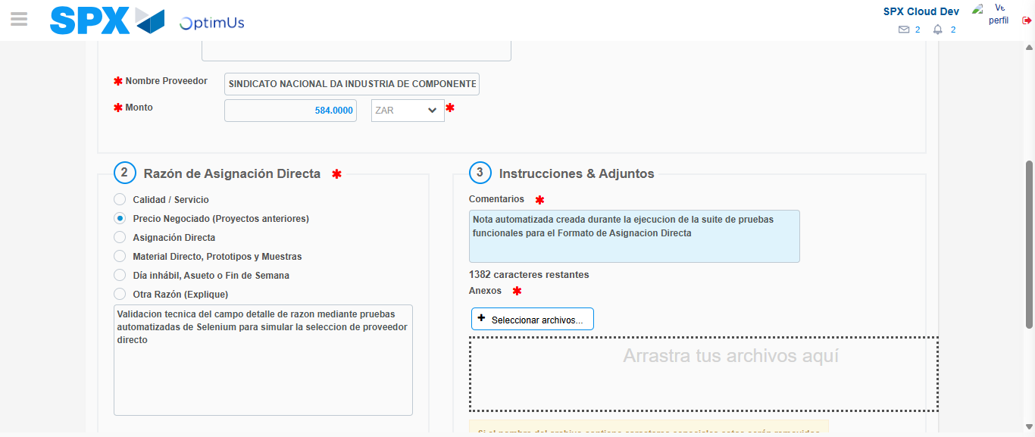Image file-name: QC_Testing-tc002_SPX_Dev5_Crear_Requisicion_Spot_Con_FAD_Tipo_Cobro_CC-1789484329343

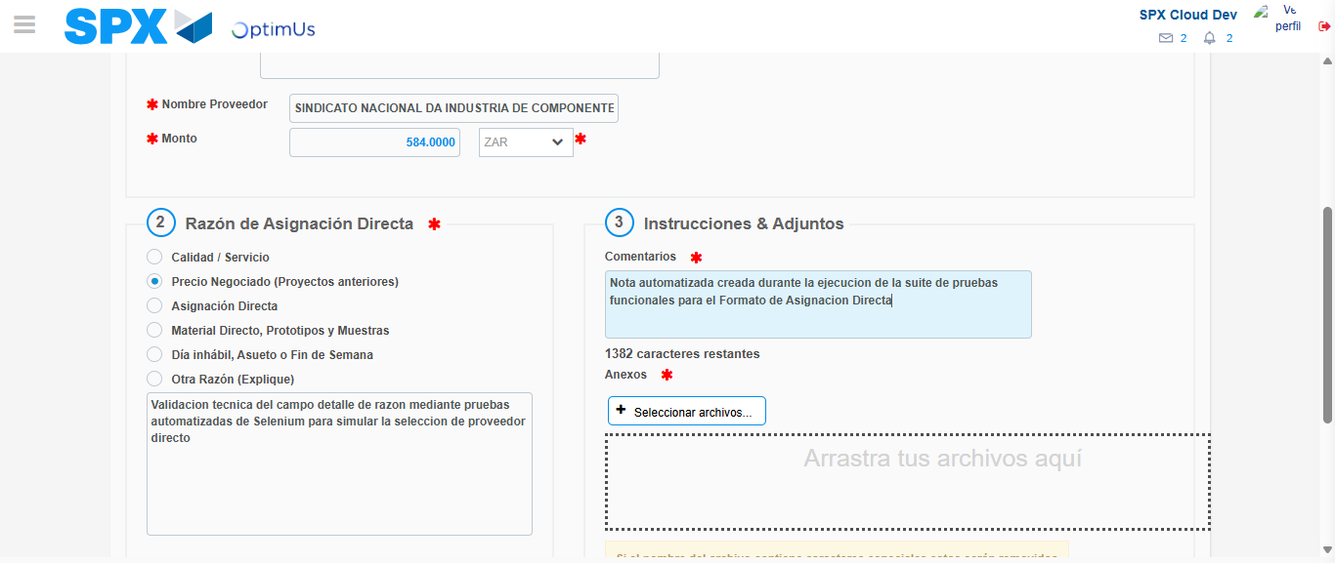Image file-name: QC_Testing-tc002_SPX_Dev5_Crear_Requisicion_Spot_Con_FAD_Tipo_Cobro_CC-1789484329904

Step 4 - Data Capture Spot Buy Requisition: Data captured correctly
Image file-name: QC_Testing-tc002_SPX_Dev5_Crear_Requisicion_Spot_Con_FAD_Tipo_Cobro_CC-1789484305146

Image file-name: QC_Testing-tc002_SPX_Dev5_Crear_Requisicion_Spot_Con_FAD_Tipo_Cobro_CC-1789484305290

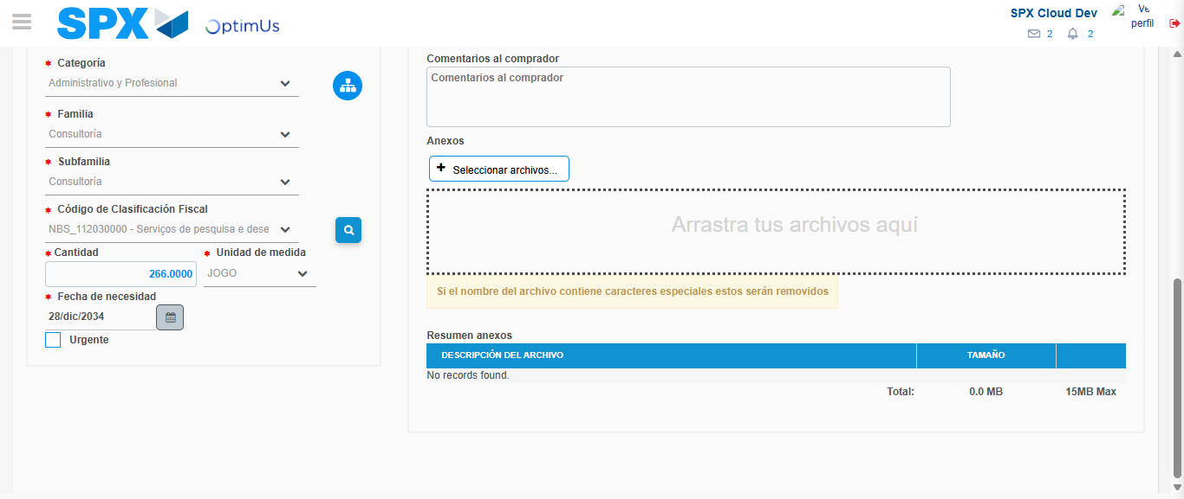Image file-name: QC_Testing-tc002_SPX_Dev5_Crear_Requisicion_Spot_Con_FAD_Tipo_Cobro_CC-1789484347774

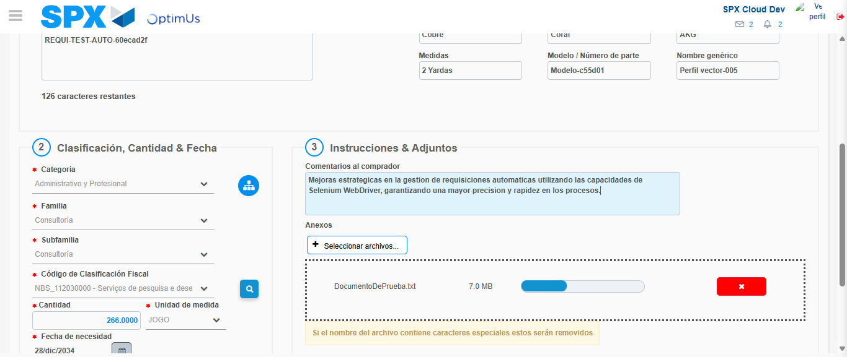Image file-name: QC_Testing-tc002_SPX_Dev5_Crear_Requisicion_Spot_Con_FAD_Tipo_Cobro_CC-1789484348584

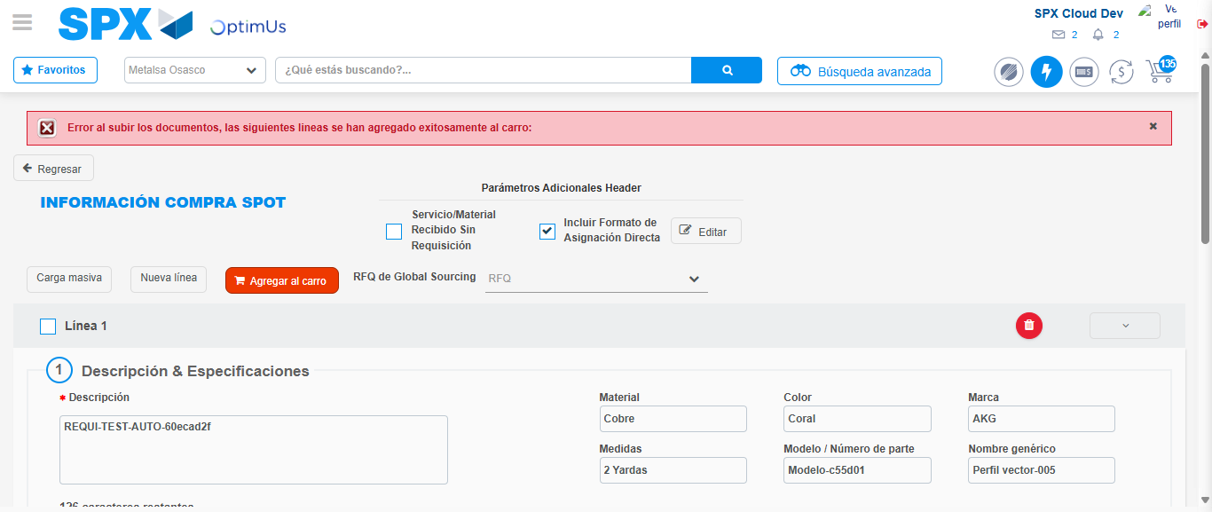Image file-name: QC_Testing-tc002_SPX_Dev5_Crear_Requisicion_Spot_Con_FAD_Tipo_Cobro_CC-1789484367224

Step 8 - Return to Main Page SPX : Return to Main Page SPX
Image file-name: QC_Testing-tc002_SPX_Dev5_Crear_Requisicion_Spot_Con_FAD_Tipo_Cobro_CC-1789484299737

Image file-name: QC_Testing-tc002_SPX_Dev5_Crear_Requisicion_Spot_Con_FAD_Tipo_Cobro_CC-1789484300297

Image file-name: QC_Testing-tc002_SPX_Dev5_Crear_Requisicion_Spot_Con_FAD_Tipo_Cobro_CC-1789484304909

Image file-name: QC_Testing-tc002_SPX_Dev5_Crear_Requisicion_Spot_Con_FAD_Tipo_Cobro_CC-1789484369442

Image file-name: QC_Testing-tc002_SPX_Dev5_Crear_Requisicion_Spot_Con_FAD_Tipo_Cobro_CC-1789484369566

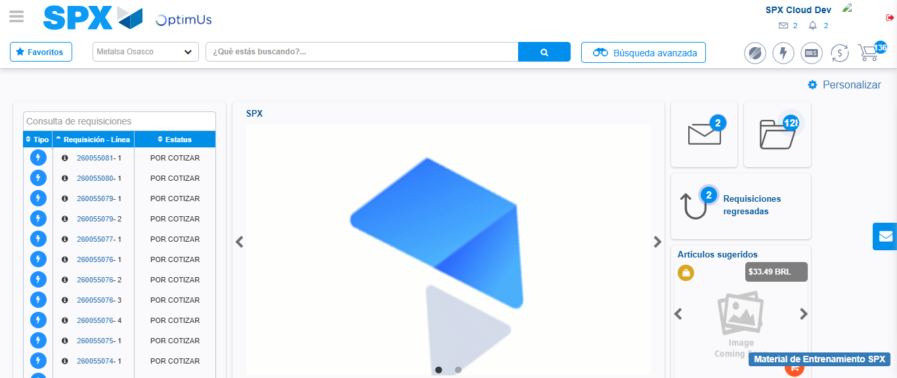Image file-name: QC_Testing-tc002_SPX_Dev5_Crear_Requisicion_Spot_Con_FAD_Tipo_Cobro_CC-1789484391017

Step 9 - Log Out : Log Out SPX
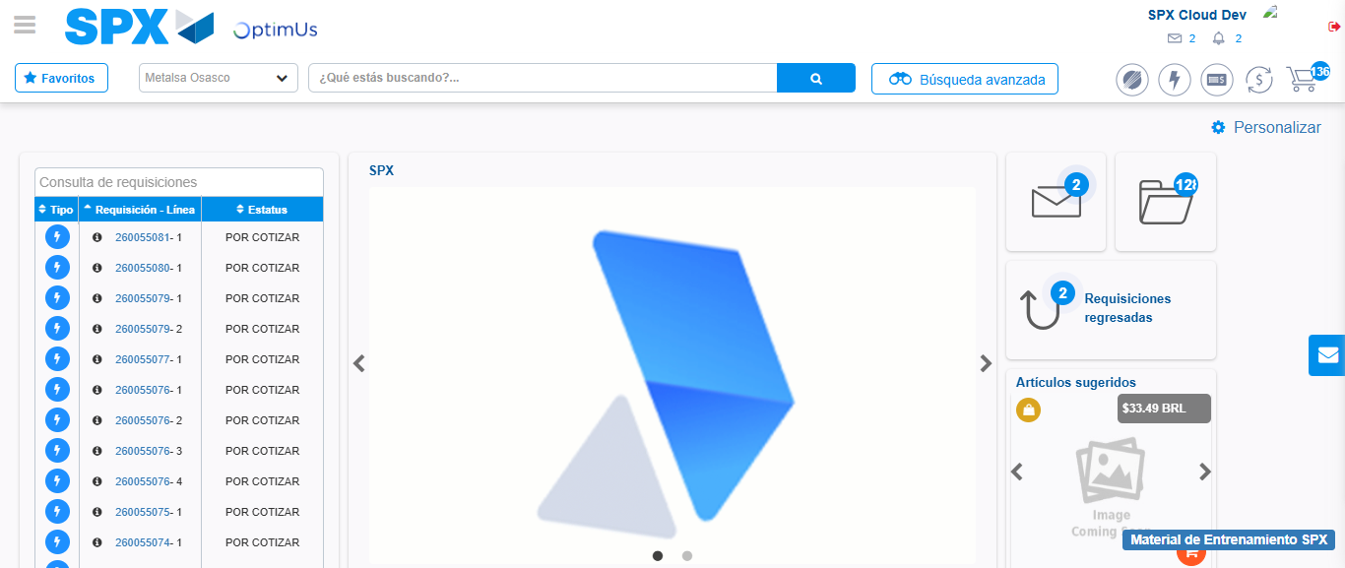Image file-name: QC_Testing-tc002_SPX_Dev5_Crear_Requisicion_Spot_Con_FAD_Tipo_Cobro_CC-1789484391273

